Review

Tortilla Flat by John Steinbeck

Outside of Monterey, California Danny lives with his good friends Pilon, Pablo, Jesus Maria, Big Joe Portagee, Johnny Pom-pom, Tito Ralph and the Pirate with his dogs. Together they share a great friendship which is based on huge trust to each other, you can say that their motto is “all for one and one for all”. They are poor paisanos, a mixure of spanish, indian and mexican blood, and live on the streets of a town called Tortilla Flat. They live a quiet happy life with only one concern: to get in hold of the daily gallon of wine. The wine is the highlight of every day, but it can sometimes be hard for the friends to get because each gallon costs one dollar. But when Danny returnes from the army and finds out that he is a heir of two houses, the lifes of the friends change. Danny becomes a respected man in Tortilla Flat, now that he owns two houses, and his good friends don’t have to worry about not having a roof over their heads as they rent Dannys second house. But the responsibility of owning the houses makes Danny feel a bit run down and the relationship to his friends is not what it used to be.

One morning Danny is disappeared and the friends can’t find him anywhere. Time goes by and his friends start to worry as they haven’t heard of him for days, there are rumours that Danny loafes around the streets of Tortilla Flat at night, stealing, drinking wine and getting into fights. The friends are very worried and decides to get Danny well once and for all...

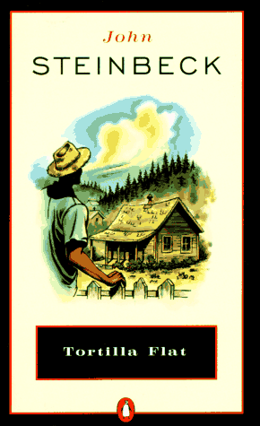
In the beginning this book seemed totally uninteresting and boring to me. Only the look at it made me concerned, and neither the title nor the writer seemed tempting. But after a while the book got more and more fascinating, you got to know all of Danny’s friends and the rest of the poeple in town.
There are many crazy incidents in the book like when Danny gives Cornelia Ruiz a vacuum cleaner, but what none of them think of is that there is no electricity in Cornelia’s house. Or the prison guard in town who himself has spend a long time behind the bars. He is an excellent guard except when he drinks too much wine and forgets that he is supposed to guard the jail and runs away together the rest of the prisoners.

The language used in the book was different from the english of today, it was sometimes a bit difficult to understand, with words like “thou” and “hast” and “sittest”. But that didn’t make it hard to read, it was a easy book which wasn’t too thick, and very fun to read.

The book was written in 1938 by John Steinbeck, who has recieved both the Pulitzerprize and the Nobelprize in literature. He was born in 1902 in a town called Salinas in California, which may be the reason how he could describe these people in Tortilla Flat so well.

